The 5 basic **financial statements** are:

* Balance Sheet
* Income Statement
* Statement of Cash Flows
* Statement of Changes in Equity
* Notes to Financial Statements.

Most common mistakes are not categorizing expenses correctly.

Mixing business with personal spending. Can make categorizing expenses harder to understand and balance.

Assets= Liabilities + Equity

Examples of assets include cash, inventory, accounts receivable, property, equipment, investments, patents, trademarks, and goodwill. Liabilities encompass loans, mortgages, accounts payable, accrued expenses, deferred revenue, bonds payable, and lease obligations.

Credit: <https://www.bajajfinserv.in/investments/assets-and-liabilities>

**Current Assets are business assets.** That you would expect to **convert to cash within a—typically, one-year—operating cycle.** Your current assets can be existing cash, the inventory you plan to sell, supplies you need for a service, your investments, or other cash equivalents.

Typically, businesses calculate their operating cycles yearly. However, some businesses will have extended operating cycles that exceed a year. Either way, your current assets will still be determined by what you can turn into cash during that cycle.

Credit:

<https://quickbooks.intuit.com/r/covid-19/current-assets-small-business/>

Types of Current Assets

* Cash and Cash Equivalents.
* Marketable Securities.
* Accounts Receivable.
* Inventory.
* Prepaid Liabilities/Expenses.
* Other Short-Term Investments.

On the balance sheet, the **Current Asset** sub-accounts are normally displayed in order of current asset liquidity. The assets most easily converted into cash are ranked higher by the finance division or accounting firm that prepared the report. The order in which these accounts appear might differ because each business can account for the included assets differently.

Cash and Cash Equivalents

By definition, assets in the Current Assets account are cash or can be quickly converted to cash. Cash equivalents are certificates of deposit, money market funds, short-term government bonds, and Treasury bills.

**Current Assets = C + CE + I + AR + MS + PE + OLA**

Where:

C = Cash

CE = Cash Equivalents

I = Inventory

AR = Accounts Receivable

MS = Marketable Securities

PE = Prepaid Expenses

OLA = Other Liquid Assets

Current Assets are listed as above. Then are calculated or using sum to add up these into the **Total Current Assets**. That follow the list of these. That helps in seeing the balance when needed.

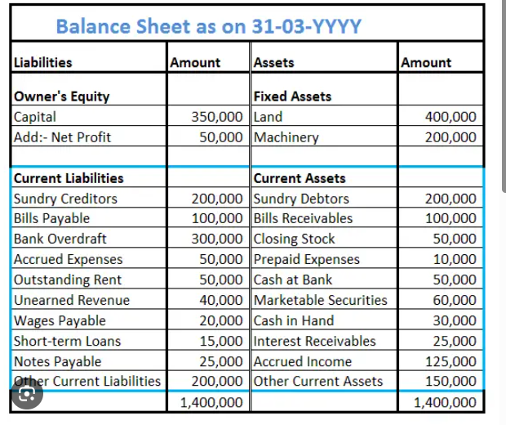

Credit: https://www.google.com/url?sa=i&url=https%3A%2F%2Fwww.accountingcapital.com%2Fquestion%2Fcan-you-please-share-a-list-of-current-assets-current-liabilities

To qualify as current assets, these items must not have any restrictions that inhibit their short-term liquidity.

What Are 3 Types of Current Assets?

Of the many types of Current Assets accounts, three are **Cash and Cash Equivalents, Marketable Securities, and Prepaid Expenses.**

Credit: <https://www.investopedia.com/terms/c/currentassets.asp>

These statements provide a comprehensive overview of a company's financial performance and position.

**Operating expenses:**

Subscriptions;

Fees;

Office Costs;

The Expanded Accounting Equation This expanded equity portion of the equation allows the user of financial accounting information to see the changes in equity. In it's entirety, the expanded equation looks like this:

**Assets = Liabilities + Owner Contributions – Owner Withdrawals + Revenues – Expenses.**

In addition, most companies capture expenses at a more detailed level, using accounts such as Rent Expense, Payroll Expense, Insurance Expense, and more.

Credit: <https://courses.lumenlearning.com/wm-accountingformanagers/chapter/accounting-equation/>

What is overstated income?

If a company overstates assets or understates liabilities it will result in an overstated net income, which carries over to the balance sheet as retained earnings and therefore inflates shareholders' equity.Feb 7, 2025

Credit: <https://www.investopedia.com/articles/fundamental-analysis/10/creative-accounting-balance-sheet.asp>

A **sub-account** is a smaller, nested account within a larger primary account, used for more detailed tracking of financial activities. It allows businesses and individuals to categorize and manage funds for different purposes, without needing multiple separate accounts. Sub-accounts can be used to track expenses by department, project, or specific activity, providing a more granular view of financial data.

How sub-accounts are created:

* Sub-accounts are typically created within a specific accounting or budgeting software, such as QuickBooks.
* The process usually involves defining the main account and then **creating the sub-accounts within that main account**.

Raw materials are a **debit** to your inventory asset column and a **credit** to your cash or accounts payable liabilities column. That also makes raw materials a **liquid asset.**